
MIT School of Management,Pune

A
Project Report
On

Project Title

Submitted By:
Student name
15MCA0XX

Under Guidance of
Prof. Dinesh Banswal

Academic Year
2015-16

CERTIFICATE

This is to certify that Mr/Ms.______________________ Roll Number 14MCA0XX of MAEER’s MIT School of Management has successfully completed the Project work titled ‘Portfolio Management System’ in partial fulfillment of requirement of RDBMS Project for MCA (Management) SEM-I as prescribed by the Savitribai Phule Pune University.

This is a record of authentic work carried out during the academic year 2015-2016

Mr. Dinesh Banswal | Dr.(Mrs.)Shubhlaxmi S. Joshi | Dr. (Mrs.) Sayalee Gankar
Internal Examiner | Department Head (MCA) | Director MITSOM
Declaration

This declaration is part of the project work entitled Project Title is submitted as part of academic requirement for Semester I of MCA (Management) to the Savitribai Phule Pune University.
I, Student Name, 15MCA0XX, solely declare that
- I will not use any unfair means to complete the project.
- I will follow the discipline and the rules of the organization where I am doing the project.
- I will not do or be part of any act which may impact the college reputation adversely.

The information I have given is true, complete and accurate. I understand that failure to give truthful, incomplete and inaccurate information may result in cancellation of my project work.

Date :
Place : Pune Signature of Student

INDEX

Sr. No | Content | Page No.
1 | Introduction, Objective & Scope of the Project
2 | Software Requirements
3 | Introduction to the Database used
4 | ER Diagram
5 | Data Dictionary
6 | Database Schema
7 | DDL Exercises
8 | DML Exercises
9 | Distinct, Order by Exercises
10 | Aggregate functions Exercises
11 | Group by Exercises
12 | Joins
13 | Views

INTRODUCTION

OBJECTIVES

SCOPE OF THE SYSTEM
Portfolio management is a continuous process. It is a dynamic activity.

The following are the basic operations of a portfolio management:

a) Monitoring the performance of portfolio by incorporating the latest market conditions.
b) Identification of the investor's objective, constraints and preferences.
c) Making an evaluation of portfolio income (comparison with targets and achievement).
d) Making revision in the portfolio.
e) Implementation of the strategies in tune with investment objectives.

SYSTEM REQUIREMENTS

The environment requirements consist of two requirements for these systems are as follows:

MINIMUM HARDWARE REQUIREMENT

PROCESSOR :
HARD DISK :
RAM :

MINIMUM SOFTWARE REQUIREMENT

OPERATING SYSTEM :
SYSTEM SOFTWARE :

INTRODUCTION TO THE DATABASE USED

The Oracle Database (commonly referred to as Oracle RDBMS or simply as Oracle) is an object-relational database management system produced and marketed by Oracle Corporation.
Larry Ellison and his friends, former co-workers Bob Miner and Ed Oates, started the consultancy Software Development Laboratories (SDL) in 1977. SDL developed the original version of the Oracle software. The name Oracle comes from the code-name of a CIA-funded project Ellison had worked on while previously employed by Ampex.

FEATURES:
- Active Session History (ASH), the collection of data for immediate monitoring of very recent database activity.
- Automatic Workload Repository (AWR), providing monitoring services to Oracle database installations from Oracle version 10. Prior to the release of Oracle version 10, the Statspack facility provided similar functionality.
- Cluster ware.
- Data Aggregation and Consolidation
- Data Guard for high availability.
- Generic Connectivity for connecting to non-Oracle systems.
Data Pump utilities, which aid in importing and exporting data and metadata between databases.
ENTITY RELATIONSHIP DIAGRAM

ID

GOES TO
HAS
ISA
HAS
NAME
INVESTOR
INVESTMENT BANK
PORTFOLIO MANAGER
PORTFOLIO
EQUITABLE
NON-EQUITABLE

CITY
CONT. NO.

NAME
CONTACT NO.

ID

NAME
MANAGES
ID
CONTACT NO.
COMM.
NAME
QUANTITY
UNIT PRICE
TYPE
BROKER
DATA DICTIONARY

- INVESTOR TABLE:

Field Name | Data Type | Scale | Description | Constraints
INV_ID | NUMBER | 5 | INVESTOR ID | PRIMARY KEY
INV_FNAME | VARCHAR2 | 4000 | FIRST NAME | -
INV_LNAME | VARCHAR2 | 4000 | LAST NAME | -
INV_CITY | VARCHAR2 | 4000 | CITY | -
INV_CONT | VARCHAR2 | 10 | CONTACT NO. | -

- BROKER TABLE:

Field Name | Data Type | Scale | Description | Constraints
BROKER_ID | NUMBER | 5 | BROKER’s ID | PRIMARY KEY
BROKER_FNAME | VARCHAR2 | 4000 | FIRST NAME | -
BROKER_LNAME | VARCHAR2 | 4000 | LAST NAME | -
BROKER_CITY | VARCHAR2 | 4000 | CITY | -
BROKER_CONT | VARCHAR2 | 10 | CONTACT NO. | -
BROKER_COMM | VARCHAR2 | 10 | COMMISSION | -
BROKER_STATE | VARCHAR2 | 20 | STATE | -

- PORTFOLIO_MANAGER TABLE:

Field Name | Data Type | Scale | Description | Constraints
PORTMGR_ID | NUMBER | 5 | PORTFOLIO MGR’S ID | PRIMARY KEY
PORTMGR_FNAME | VARCHAR2 | 4000 | MGR’S FIRST NAME | -
PORTMGR_LNAME | VARCHAR2 | 4000 | MGR’S LAST NAME | -
PORTMGR_CONT | VARCHAR2 | 10 | CONTACT NO. | -
INV_ID | NUMBER | 5 | INVESTOR ID | FOREIGN KEY
PORT_ID | NUMBER | 5 | PORTFOLIO ID | FOREIGN KEY

- PORTFOLIO TABLE:

Field Name | Data Type | Scale | Description | Constraints
PORT_ID | NUMBER | 5 | PORTFOLIO ID | PRIMARY KEY
INV_ID | NUMBER | 5 | INVESTOR ID | FOREIGN KEY
FINS_ID | NUMBER | 5 | FINAN. INSTRU. ID | FOREIGN KEY
PORT_QUANTITY | NUMBER | 5 | QUANTITY | -
PORT_PRICE | NUMBER | 5 | UNIT PRICE | -
PORT_STATUS | VARCHAR2 | 10 | STATUS | -

- PORTFOLIO EXECUTION TABLE:

Field Name | Data Type | Scale | Description | Constraints
PORT_ID | NUMBER | 5 | PORTFOLIO ID | FOREIGN KEY
BROKER_ID | NUMBER | 5 | BROKER’S ID | FOREIGN KEY
PORTMGR_ID | NUMBER | 5 | PORTFOLIO MGR ID | FOREIGN KEY
PORT_PRICE | NUMBER | 5 | UNIT PRICE | -
PORT_STATUS | VARCHAR2 | 10 | STATUS | -
BROKER_COMM | VARCHAR2 | 4000 | BROKER COMM. | -

- FINANCIAL INSTRUMENT TABLE:

Field Name | Data Type | Scale | Description | Constraints
FINS_ID | NUMBER | 5 | FINAN. INSTRU ID | PRIMARY KEY
FINS_TYPE | VARCHAR2 | 4000 | FINAN. INSTRU TYPE | -
FINS_NAME | VARCHAR2 | 4000 | FINAN. INSTRU NAME | -
FINS_QUANTITY | VARCHAR2 | 5 | QUANTITY | -
FINS_UNITPRICE | NUMBER | 5 | UNIT PRICE | -

DATABASE SCHEMA

- BROKER TABLE:

CREATE TABLE “BROKER"
(
"BROKER_ID" NUMBER NOT NULL ENABLE,
"BROKER_FNAME" VARCHAR2 (4000),
"BROKER_LNAME" VARCHAR2 (4000),
"BROKER_CITY" VARCHAR2 (4000),
"BROKER_CONT" VARCHAR2 (10),
"BROKER_COMM" VARCHAR2 (10),
"BROKER_STATE" VARCHAR2 (20),
CONSTRAINT "BROKER_PK" PRIMARY KEY ("BROKER_ID") ENABLE
)

- INVESTOR TABLE:

CREATE TABLE "INVESTOR"
(
"INV_ID" NUMBER NOT NULL ENABLE,
"INV_FNAME" VARCHAR2 (4000),
"INV_LNAME" VARCHAR2 (4000),
"INV_CITY" VARCHAR2 (4000),
"INV_CONT" VARCHAR2 (4000),
CONSTRAINT "INVESTOR_PK" PRIMARY KEY ("INV_ID") ENABLE
)

- PORTFOLIO TABLE:

CREATE TABLE "PORTFOLIO"
(
"PORT_ID" NUMBER NOT NULL ENABLE,
"INV_ID" NUMBER NOT NULL ENABLE,
"FINS_ID" NUMBER NOT NULL ENABLE,
"PORT_QUANTITY" NUMBER,
"PORT_PRICE" NUMBER,
"PORT_STATUS" VARCHAR2 (10),
CONSTRAINT "PORTFOLIO_PK" PRIMARY KEY ("PORT_ID") ENABLE,
CONSTRAINT "PORTFOLIO_FK" FOREIGN KEY ("INV_ID")
REFERENCES "INVESTOR" ("INV_ID") ON DELETE SET NULL ENABLE,
CONSTRAINT "PORTFOLIO_FK2" FOREIGN KEY ("FINS_ID")
REFERENCES "FINANCIAL_INSTRU" ("FINS_ID") ON DELETE SET NULL ENABLE
)

- PORTFOLIO MANAGER TABLE:

CREATE TABLE "PORTFOLIO_MANAGER"
(
"PORTMGR_ID" NUMBER NOT NULL ENABLE,
"PORTMGR_FNAME" VARCHAR2 (4000),
"PORTMGR_LNAME" VARCHAR2 (4000),
"PORTMGR_CONT" VARCHAR2 (10),
"INV_ID" NUMBER NOT NULL ENABLE,
"PORT_ID" NUMBER NOT NULL ENABLE,
CONSTRAINT "PORTFOLIO_MANAGER_PK" PRIMARY KEY ("PORTMGR_ID") ENABLE,
CONSTRAINT "PORTFOLIO_MANAGER_FK3" FOREIGN KEY ("INV_ID")
REFERENCES "INVESTOR" ("INV_ID") ON DELETE SET NULL ENABLE,
CONSTRAINT "PORTFOLIO_MANAGER_FK4" FOREIGN KEY ("PORT_ID")
REFERENCES "PORTFOLIO" ("PORT_ID") ON DELETE SET NULL ENABLE
)
- PORTFOLIO EXECUTION TABLE:

CREATE TABLE "PORTFOLIO_EXEC"
(
"PORT_ID" NUMBER NOT NULL ENABLE,
"BROKER_ID" NUMBER NOT NULL ENABLE,
"PORTMGR_ID" NUMBER NOT NULL ENABLE,
"PORT_PRICE" NUMBER,
"PORT_STATUS" VARCHAR2 (10),
"BROKER_COMM" VARCHAR2 (4000),
CONSTRAINT "PORT_EXEC_FK" FOREIGN KEY ("PORT_ID")
REFERENCES "PORTFOLIO" ("PORT_ID") ON DELETE SET NULL ENABLE,
CONSTRAINT "PORT_EXEC_FK2" FOREIGN KEY ("BROKER_ID")
REFERENCES "BROKER" ("BROKER_ID") ON DELETE SET NULL ENABLE,
CONSTRAINT "PORT_EXEC_FK3" FOREIGN KEY ("PORTMGR_ID")
REFERENCES "PORTFOLIO_MANAGER" ("PORTMGR_ID") ON DELETE SET NULL ENABLE
)

- FINANCIAL INSTRUMENT TABLE:

CREATE TABLE "FINANCIAL_INSTRU"
(
"FINS_ID" NUMBER NOT NULL ENABLE,
"FINS_TYPE" VARCHAR2 (4000),
"FINS_NAME" VARCHAR2 (4000),
"FINS_QUANTITY" VARCHAR2 (5),
"FINS_UNITPRICE" NUMBER,
CONSTRAINT "FINANCIAL_INSTRU_PK" PRIMARY KEY ("FINS_ID") ENABLE
)
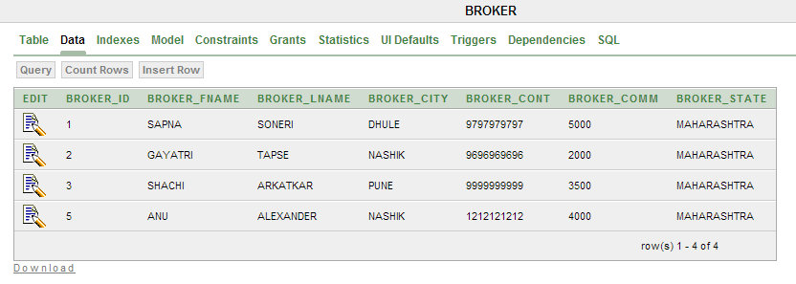

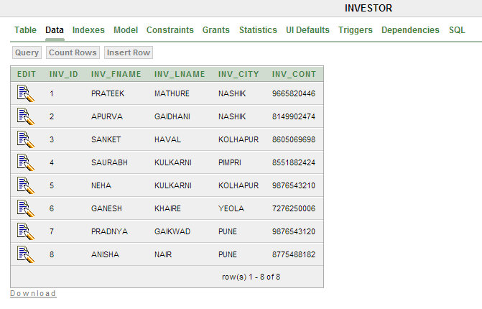

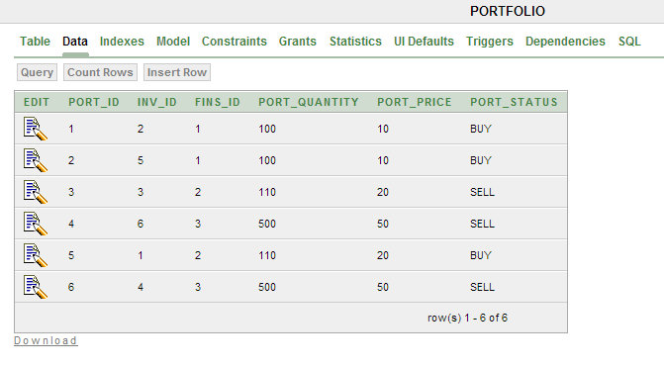

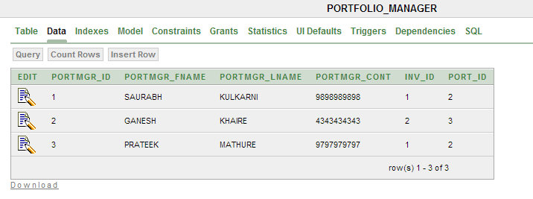

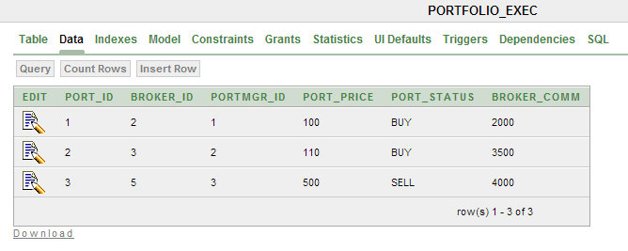

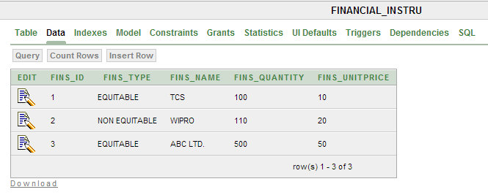

DDL EXERCISES

- CREATE:

CREATE TABLE INVESTOR
( "INV_ID" NUMBER NOT NULL ENABLE,
"INV_FNAME" VARCHAR2 (4000),
"INV_LNAME" VARCHAR2 (4000),
"INV_CITY" VARCHAR2 (4000),
"INV_CONT" VARCHAR2 (4000),
CONSTRAINT "INVESTOR_PK" PRIMARY KEY ("INV_ID") ENABLE
);

- INSERT:

INSERT INTO INVESTOR VALUES (8,'PRATEEK','MATHURE','NASHIK','8775488182');

- ALTER:

ALTER TABLE BROKER
ADD BROKER_STATE VARCHAR2 (20);

- TRUNACTE:

TRUNCATE TABLE PORTFOLIO;

- DROP:

DROP TABLE PORTFOLIO_MANAGER;

DML EXERCISES

- UPDATE:

UPDATE INVESTOR
SET INV_FNAME='PRATEEK'
WHERE INV_ID=2;

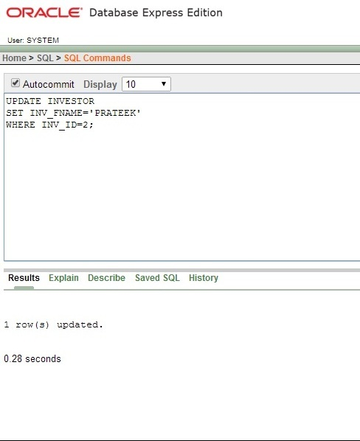

- DELETE:

DELETE FROM BROKER
WHERE BROKER_ID=4;

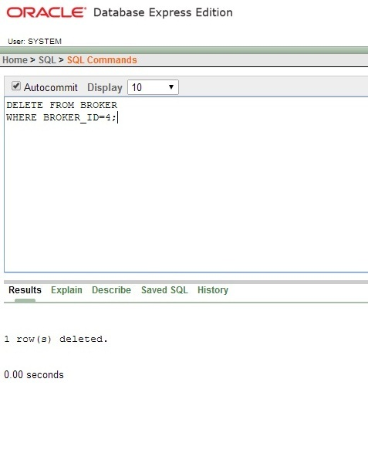

- SELECT:

SELECT *
FROM PORTFOLIO;

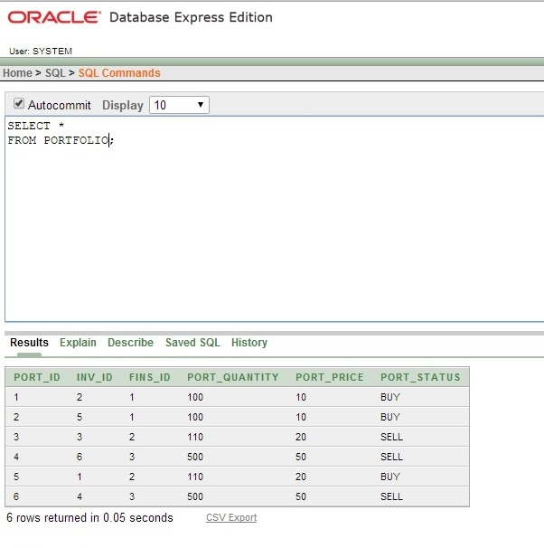
DISTINCT & ORDER BY EXERCISES

- DISTINCT:

SELECT DISTINCT FINS_TYPE
FROM FINANCIAL_INSTRU;

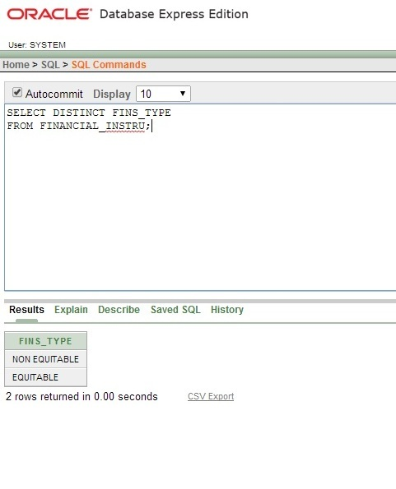
2. ORDER BY:

SELECT PORT_ID
FROM PORTFOLIO_MANAGER
ORDER BY PORT_ID DESC;

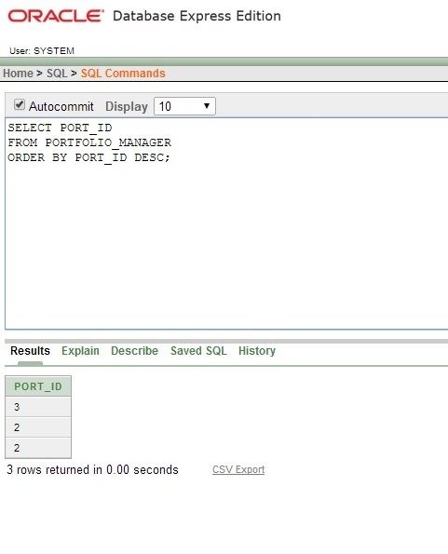
AGGREGATE FUNCTION EXERCISE

- AGGREGATE FUNCTION:

SELECT COUNT (*) FROM BROKER;

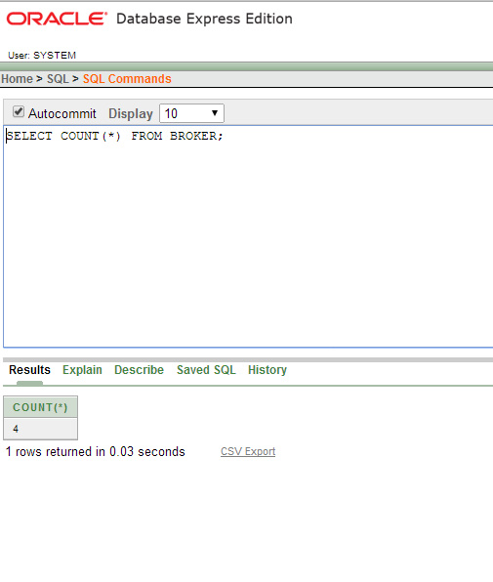
GROUP BY EXECISES

SELECT INV_LNAME FROM INVESTOR
WHERE INV_CITY='NASHIK'
GROUP BY INV_LNAME;

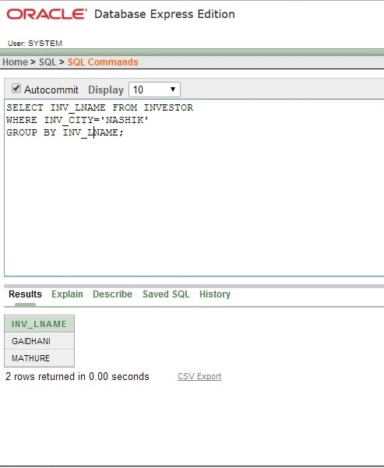
SELECT BROKER_ID FROM BROKER
WHERE BROKER_CITY='DHULE'
GROUP BY BROKER_ID;

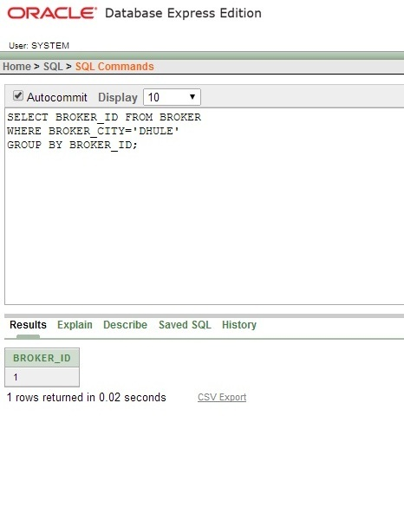
SELECT PORTMGR_FNAME
FROM PORTFOLIO_MANAGER
WHERE PORT_ID=2
GROUP BY PORTMGR_FNAME;

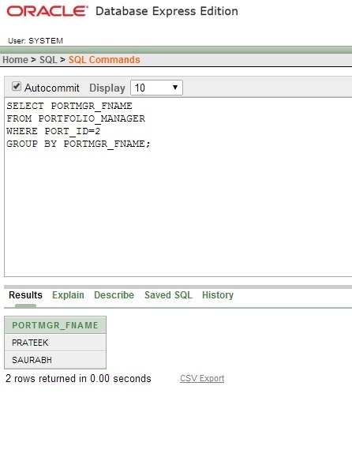
JOINS

INNER JOIN:

SELECT INV_FNAME, PORTMGR_FNAME
FROM INVESTOR
INNER JOIN PORTFOLIO_MANAGER ON INVESTOR.INV_ID=PORTFOLIO_MANAGER.INV_ID;

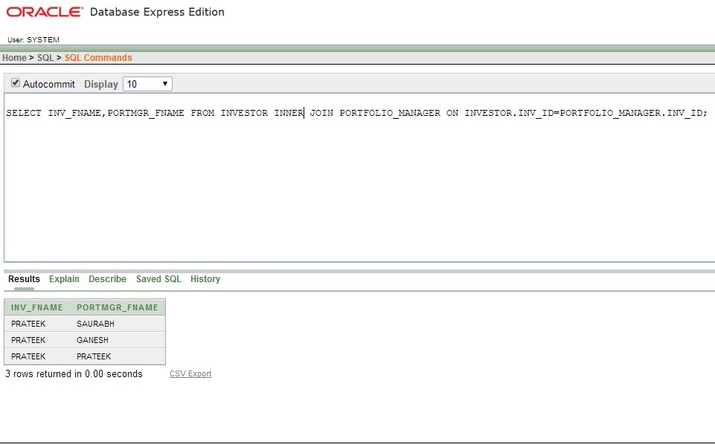
LEFT JOIN:

SELECT INV_FNAME, PORT_STATUS
FROM PORTFOLIO LEFT JOIN INVESTOR ON PORTFOLIO.INV_ID=INVESTOR.INV_ID;
RIGHT JOIN:

SELECT INV_FNAME, PORT_STATUS
FROM PORTFOLIO RIGHT JOIN INVESTOR ON PORTFOLIO.INV_ID=INVESTOR.INV_ID

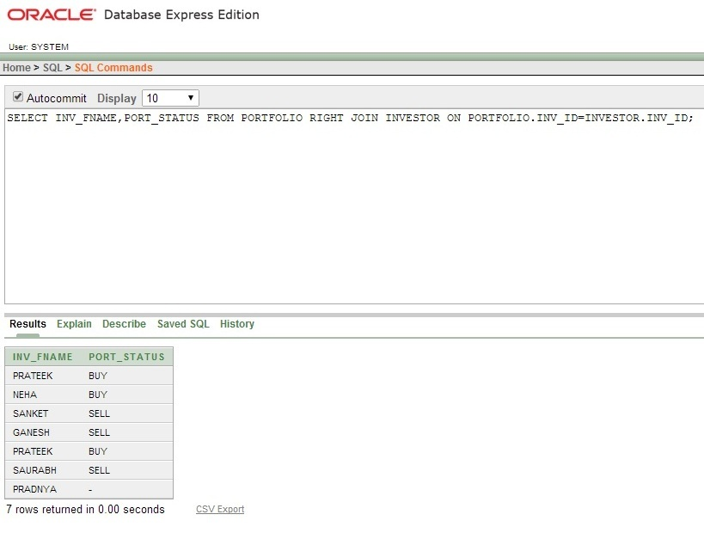
FULL JOIN:

SELECT INV_FNAME, PORT_STATUS
FROM PORTFOLIO FULL JOIN INVESTOR ON PORTFOLIO.INV_ID=INVESTOR.INV_ID;

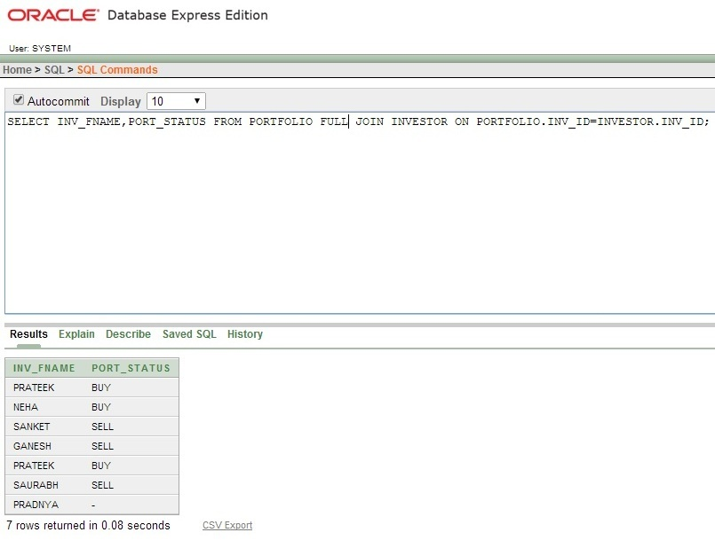
VIEWS

1.CREATE OR REPLACE FORCE VIEW "BROK" ("BROKER_FNAME", "BROKER_LNAME") AS
SELECT BROKER_FNAME, BROKER_LNAME FROM BROKER

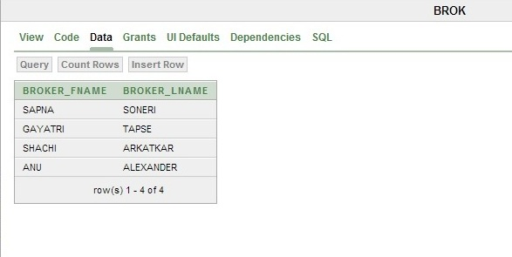

- CREATE OR REPLACE FORCE VIEW "INV" ("INV_ID", "INV_FNAME", "INV_LNAME", "INV_CITY", "INV_CONT") AS
SELECT "INV_ID","INV_FNAME","INV_LNAME","INV_CITY","INV_CONT" FROM INVESTOR

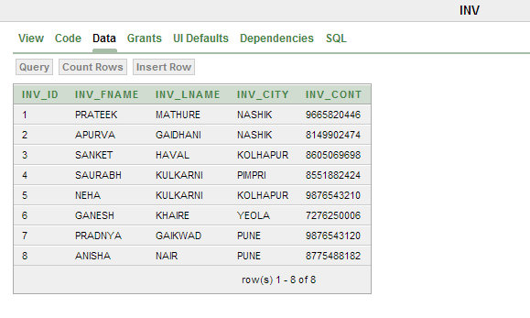

- CREATE OR REPLACE FORCE VIEW "PORTMGR" ("PORTMGR_ID", "PORTMGR_FNAME", "PORTMGR_CONT") AS
SELECT PORTMGR_ID, PORTMGR_FNAME, PORTMGR_CONT FROM PORTFOLIO_MANAGER

